Project Planning Phase
Project Planning — Implement Client Script & UI Policy (Incident)

Product Backlog, Sprint Schedule, and Estimation (4 Marks)
The product backlog and sprint schedule below are tailored to the ServiceNow Incident implementation and aligned with the six project milestones.

Project Tracker, Velocity & Burndown Chart: (4 Marks)



https://www.visual-paradigm.com/scrum/scrum-burndown-chart/
https://www.atlassian.com/agile/tutorials/burndown-charts

Reference:
https://www.atlassian.com/agile/project-management
https://www.atlassian.com/agile/tutorials/how-to-do-scrum-with-jira-software
https://www.atlassian.com/agile/tutorials/epics
https://www.atlassian.com/agile/tutorials/sprints
https://www.atlassian.com/agile/project-management/estimation
https://www.atlassian.com/agile/tutorials/burndown-charts

IMPLEMENT CLIENT SCRIPT & UI POLICY (INCIDENT)
Project Name | Implement Client Script & UI Policy (Incident)
Team ID | TBD
Maximum Marks | 5 Marks
Planning Approach | Agile / Scrum — 2 Sprints
1. Product Backlog & Sprint Schedule
Sprint | Functional Requirement (Epic) | User Story No. | User Story / Task | Story Points | Priority | Team Members
Sprint-1 | UI Policy Configuration | USN-1 | Create UI Policy on Incident | 3 | High | Team
Sprint-1 | UI Policy Configuration | USN-2 | Create UI Policy Action – Urgency | 2 | High | Team
Sprint-1 | UI Policy Configuration | USN-3 | Configure mandatory/read-only field behavior | 3 | High | Team
Sprint-1 | UI Policy Configuration | USN-4 | Test UI Policy and reverse-if-false behavior | 2 | Medium | Team
Sprint-2 | Client Script & Validation | USN-5 | Create onChange Client Script | 3 | High | Team
Sprint-2 | Client Script & Validation | USN-6 | Create onSubmit Client Script — Save Validation | 3 | High | Team
Sprint-2 | Client Script & Validation | USN-7 | Create onCellEdit Client Script | 3 | High | Team
Sprint-2 | Client Script & Validation | USN-8 | Integration and configuration testing | 2 | High | Team
2. Project Tracker, Velocity & Sprint Schedule
Sprint | Total Story Points | Duration | Sprint Start Date | Sprint End Date (Planned) | Story Points Completed | Sprint Release Date (Actual)
Sprint-1 | 10 | TBD | TBD | TBD | TBD | TBD
Sprint-2 | 11 | TBD | TBD | TBD | TBD | TBD
Velocity Calculation
Total planned story points = 10 + 11 = 21
Number of sprints = 2
Planned average velocity = 21 / 2 = 10.5 story points per sprint
3. Burndown Chart
The burndown chart represents the planned reduction of remaining work across the implementation. The project begins with 21 story points and reaches 0 when all planned stories are completed.
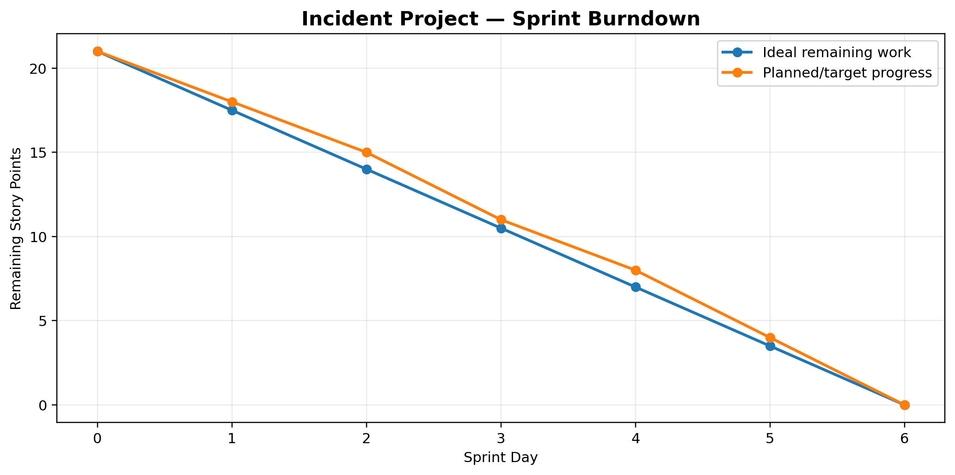
4. Milestone Alignment
Milestone 1 — Create UI Policy on Incident → Sprint-1 / USN-1
Milestone 2 — Create UI Policy Action – Urgency → Sprint-1 / USN-2
Milestone 3 — Create onChange Client Script → Sprint-2 / USN-5
Milestone 4 — Create onSubmit Client Script (Save Validation) → Sprint-2 / USN-6
Milestone 5 — Create onCellEdit Client Script → Sprint-2 / USN-7
Milestone 6 — Testing the Configuration → Sprint-1 USN-4 + Sprint-2 USN-8
Conclusion → Demonstrate a consistent, validated Incident workflow.
Planning Note: Sprint dates and completed points are left as TBD until the actual team schedule and execution results are available.

